Given two nodes of a binary tree p and q, return *their lowest common ancestor (LCA)*.

Each node will have a reference to its parent node. The definition for Node is below:

class Node {

public int val;

public Node left;

public Node right;

public Node parent;

}

According to the [**definition of LCA on Wikipedia**](https://en.wikipedia.org/wiki/Lowest_common_ancestor): "The lowest common ancestor of two nodes p and q in a tree T is the lowest node that has both p and q as descendants (where we allow **a node to be a descendant of itself**)."

**Example 1:**

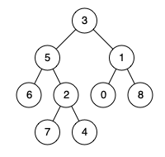

**Input:** root = [3,5,1,6,2,0,8,null,null,7,4], p = 5, q = 1

**Output:** 3

**Explanation:** The LCA of nodes 5 and 1 is 3.

**Example 2:**



**Input:** root = [3,5,1,6,2,0,8,null,null,7,4], p = 5, q = 4

**Output:** 5

**Explanation:** The LCA of nodes 5 and 4 is 5 since a node can be a descendant of itself according to the LCA definition.

**Example 3:**

**Input:** root = [1,2], p = 1, q = 2

**Output:** 1

**Constraints:**

* The number of nodes in the tree is in the range [2, 105].
* -109 <= Node.val <= 109
* All Node.val are **unique**.
* p != q
* p and q exist in the tree.